Reformation ABCs

N is for Ninety-Five Theses
On Tuesday, October 31, 2017, many people will celebrate Halloween. For Lutherans and others, that date will also mark the 500th anniversary of the day when, according to legend, Dr. Martin Luther, Augustinian monk and professor of Bible, nailed the Ninety-Five Theses to the door of the Castle Church in Wittenberg, Germany. Subtitled a “Disputation on the Power and Efficacy of Indulgences,” the Ninety-Five Theses were Luther’s academic challenge to the practices of the day, not intended as church-dividing doctrine. The document was soon printed and distributed widely. By December it had been translated from its original Latin into German, and by March 1518 it was generally known throughout Germany.
The statements are based on Luther’s essential conviction that we cannot be saved by good works but solely by grace—God’s unconditional love. Mediation or intercession by a priest is not necessary.
Opposing church practice, Luther stated (among other things) that “selling indulgences to finance the building of St. Peter’s [basilica in Rome] is wrong”; that “the pope has no power over purgatory”; and that “buying indulgences gives people a false sense of security and endangers their salvation.”
Not surprisingly, the Theses caused a great “sensation” and divisions within the Catholic Church, leading eventually to the Protestant Reformation.
Carol Ann Ellis, Synodically Authorized Lay Minister (Northeast Pennsylvania synod)
Current member: St. Peter’s Lutheran Church, Ocean City, Maryland

O is for On the Jews and their Lies
Our observation of Reformation 500 calls us to confession and lament as well as to celebration. Martin Luther’s virulent anti-Jewish writings stained his legacy and reverberated over the centuries with horrific consequences.
Luther initially believed that Jews could be converted to Christianity and criticized harsh treatment of them in his 1523 book That Jesus Christ Was Born a Jew. But when Jews did not convert as he had hoped, Luther wrote several vicious attacks, including his 1543 On the Jews and Their Lies. In it he described the Jewish people as “whoring people...no people of God, and their boast of lineage, circumcision, and law must be accounted as filth.” He urged Christians to burn down synagogues and schools; destroy the houses and holy books of Jews; forbid their rabbis to preach and teach; confiscate their property; and offer no protection to them on the highways and roads.
As Hitler rose to power in the Third Reich, the German Lutheran churches that allied with him and his attacks on the Jews cited Luther’s anti-Jewish works and displayed them at rallies. One Lu-theran bishop proclaimed in 1933, “The cross of Christ and the swastika—they should and must stand alongside each other.” (About twenty percent of Lutheran congregations actively supported Hitler’s National Socialism; many others were silent and passive as Hitler escalated his attacks on the Jews and embarked on a program of mass extermination.)
On April 18, 1994, the ELCA Churchwide Assembly adopted a statement repudiating Luther’s anti-Jewish writings and legacy in a declaration that “expresses deep regret for their historical consequences, and reclaims the desire to live in ‘love and respect for Jewish people.’” http://download.elca.org/ELCA%20Resource%20Repository/Declaration_Of_The_ELCA_To_The_Jewish_Community.pdf?_ga=2.64266991.1188418994.1507298330-820792894.1504112124
Pastor Jason Churchill
St. Stephen, Wilmington, Delaware

O is for Osiander, Andreas (1498-1552)
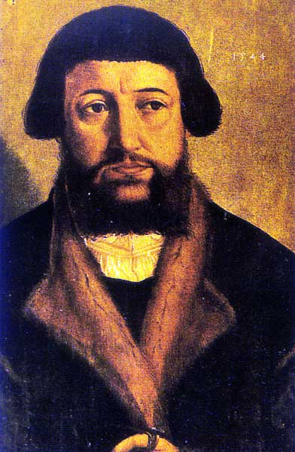
A German reformer, humanist, theologian and scientist. He pursued a wide range of disciplines at the University of Ingolstadt, mastering Greek, Hebrew and Aramaic and even study-ing the mysticism of the Jewish Kabbalah. Ordained a priest in 1520, he taught at an Augustinian convent while serving St. Lorenz church in Nuremberg, where he began instituting Lutheran reforms that would be adopted throughout the city. He continued to write, publishing a reformed version of the Vulgate, the Latin Bible, a harmony of the four gospels in Greek and an edition of Copernicus’ De revolutionibus orbium coelestium (On the revolution of the celestial spheres) with his own unauthorized preface suggesting the model as only a mathematical hypothesis, to make it more acceptable to the church. Osiander supported Lutheran reforms at the Marburg Colloquy (1529) and the Diet of Augsburg (1530) and in signing the Smalcald Articles (1537) but he stirred opposition with his mystical theology that we are justified by Christ dwelling within us and his harsh arguments. For example, he wrote, “Woe to those who preach that men of sinful walk cannot be considered pi-ous; most are furious when they hear this, as we see and experience, and would like all such preachers to be driven away or even killed; but where that cannot be done, they strengthen their hypocrite preachers with praise, comfort, presents and protection, so that they may go on happily and give no place to the truth, how-ever clear it may be.”
Pastor Bruce Davis, Wilmington, Delaware

